Pokhara University

Level: Bachelor | Semester – Spring | Year : 2008
Programme: BE |  | Full Marks: 100
Course: Electronic Devices |  | Time : 3hrs.

Candidates are required to give their answers in their own words as far as practicable.
The figures in the margin indicate full marks.

Attempt all the questions.

 | - Draw i-v characteristic curve for (i) ideal diode (ii) Real diode. Why the curve in real case is different than the ideal case? Define the terms: barrier potential, static resistance, dynamic resistance.  - For the circuits given below, find out the currents. (Assume piecewise linear model of diode).  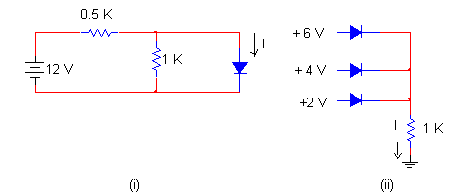 | 8  3+4
 | - The circuit given below is the zener diode regulator circuit. “The output voltage approximately remains constant even though (i) input voltage fluctuates within certain limit (ii) Load resistance varies.” Justify it.  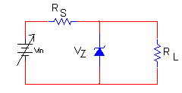  - What do you understand transition capacitance and diffusion capacitance. | 8  7
 | - Explain the output characteristic of the common emitter configuration.  - The transistor shown in the figure has V_{BE}(active) = 0.6V and β_{dc} = 75. The operating point V_{CEQ} required is 4V. Calculate R_{E} and the stability factor S. | 8  7
 | - For the amplifier shown in the figure below the transistor has the following parameters: h_{ie} = 1.1K, h_{re} = 2.5 × 10⁻⁴, h_{fe} = 50, hoe = 25 × 10⁻⁶ µA/V. Calculate Ai, Av, Avs and Ri'. | 8
 | - The transistor used in the circuit has following parameters: h_{ie} = 500Ω, h_{re} = 2.4 × 10⁻⁴, h_{fe} = 60, hoe = 1/40K, calculate (i) Vo/Vs (ii) Ri and (iii) Ro. Assume all capacitors to be very large. | 7
 | - Compare and contrast BJT and FET characteristics. Draw common source self bias nJFET and draw its small signal low frequency model. Derive the expression of its voltage gain.  - Design Voltage divider self bias n-JFET for 8mA drain current and 10V drain to source voltage. Given: I_{DSS} = 15 mA, V_{P} = -8 V, assume other data if necessary. | 4+2+2+2  5
 | - Draw Full wave Centre tap rectifier circuit and explain its operation. Derive Average output Voltage.  - How ripples of half wave rectifier can be minimized?. Compare ripple factor of half wave rectifier with that of full wave rectifier. Explain any one type of filtering circuit | 7  8
 | Write short notes on (Any Two)  - Enhancement type p-MOSFET  - High frequency t model of BJT  - r-model | 2×5

